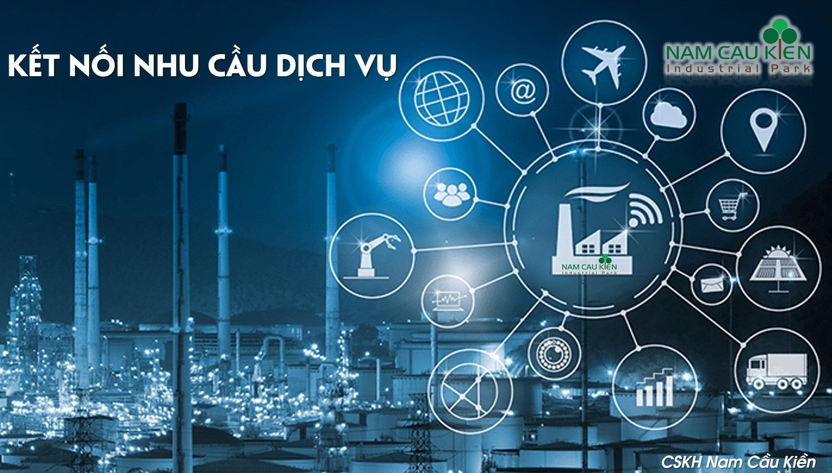

Letter of introduction
Established in 2008, invested by SHINEC Joint Stock Company, for more than 12 years of building and operating business, Nam Cau Kien Industrial Park has always focused on improving the management system, developing utility services in order to increase the benefits for customers and become a sustainable development partner of enterprises. So far, Nam Cau Kien Industrial Park has been filled in Phase 1, attracting more than 50 domestic and foreign investors, and is widely known for the first model of eco-industrial park in Hai Phong. 2020 is the year to start the Phase 2 of the project with synchronous infrastructure system, modern standards. We are gradually improving the apparatus, completing the service quality; setting the criteria for each stage and gradually completes the targets, striving to become the first Eco-Industrial Park in Vietnam owned by Vietnamese. If that goal is achieved, it will not only contribute to enhancing the brand of investors in the industrial park, the partners providing products / services for the IZ, products / services supplied by IZ, but also setting the solid foundation - an example for other industrial zones. We are also joining hands to contribute to building green, clean and beautiful industrial parks; produce and thrive together in a sustainable environment.
Customer Relationship Team - Service Management of Business Department - Shinec Joint Stock Company was established with the desire to take care and satisfy the needs of the customers who are Investors (investors) in the Industrial Park. , as well as supporting the development of Service Delivery Partners, towards the goal of creating a healthy and fair service delivery ecosystem in Nam Cau Kien Industrial Park. The Customer Relationship Team - Service Management will act as the focal point for disseminating regulations, receiving information, interacting and connecting between parties, and parties with specialized staff in each task area in the process of operating in the industrial park. To achieve that, we look forward to getting the maximum cooperation not only from investors in the industrial park, but also from companies providing products / services to the industrial park. The satisfaction, success and development of investors, partners, customers are also our joy and pride - employees of SHINEC Joint Stock Company - Nam Cau Kien Industrial Park.
STRENGTHS OF NAM CAU KIEN INDUSTRIAL PARK
÷ Possessing a favorable strategic location
÷ Known as an industrial park pioneering the construction of Ecological Industrial Park - sustainable investment environment
÷ Stable working environment - Effective recruitment.
÷ Have close connection and mutual support with Investors / Enterprises in the Industrial Park
÷ Attracted 55 Investors with diversity in Countries, industries and become potential locations for new Investors
÷ Have a good relationship with Partners, Customers inside and outside the Industrial Park

SCOPE OF OUR WORK
÷ Receive information from buyers and sellers of products / services.
÷ Make face-to-face appointments and verify needs of purchasing companies and product / service selling companies.
÷ Provide information of companies wishing to buy or sell products / services.
÷ Representing the buying or selling party of products / services in some transactions
÷ Set up face-to-face meetings between the parties
÷ Support for contract drafting and negotiation between parties
÷ Support the implementation of cooperation between the parties
REGISTER TO CONNECTING DEMAND TO BUY OR SELL PRODUCTS / SERVICES
CUSTOMER INFORMATION

 | Company’s name | Nation
 | Contact representative | Position
 | Phone number | Email address
DESCRIPTION OF REQUIREMENTS

Type of products/services | Demand (Buy / Sell)

Other detailed requirements (Please fill in the box below for other detailed requirements)

CUSTOMER / PARTNER CONFIRMATION

Company name: ……………………………………………………...
Full name: …………………………………………………………
Position: ………………………………....................................
………………….,………………

Representative
(Signature and Mark)

CONNECT

In order that we can fully support your company, please provide information in the form including:
- Capability document (including hard copy and soft copy) of the company or catalog or brochure about the products / servicse to be provided.
- The [Registration Information] form has been completely filled out and scanned (please convert to the .pdf file format
- 1 introductory article (word file with pictures in the article and images sent separately to ensure the quality of photos when posting) from 2-4 pages: Content introducing brief information about your company; the product or service intended to be provided; and typical projects. This article is to support the Partner by posting on the Nam Cau Kien IP website and promoting the products to our investors and partners.

For complete proposals, please email us and send the hard copy catalog / brochure at the address below:
Customer Relationship Team - Service Management
SHINEC Joint Stock Company
Nam Cau Kien Industrial Park - Thuy Nguyen - Hai Phong
Email: cskh.namcaukienip@gmail.com
Facebook: https://www.facebook.com/namcaukien
Website: https://namcaukien.com.vn/
For any questions, please contact us directly via hotline: 032.719.1691 (Mr.Mạnh)
077.539.2493 (Mr.Phát)
076.565.1620 (Mr.Nam)

